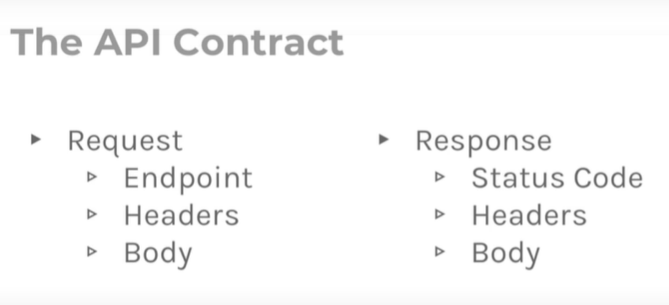

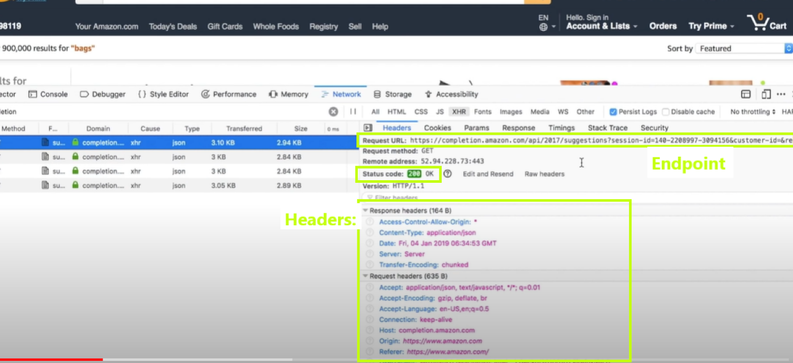

### Parameters

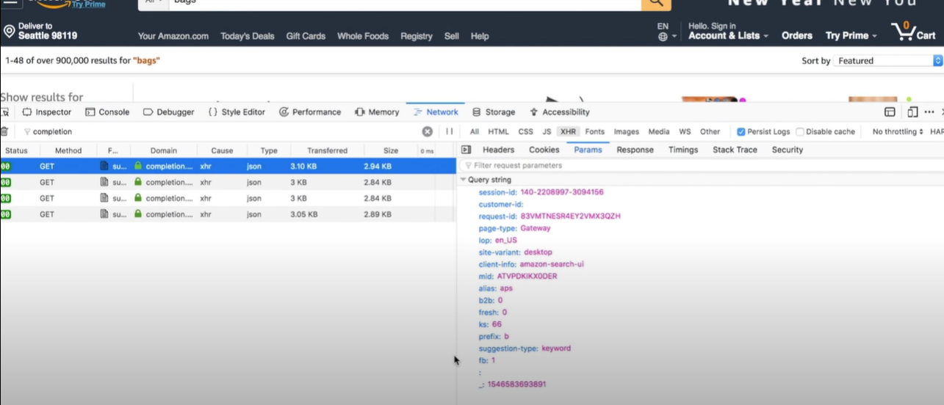

### Response

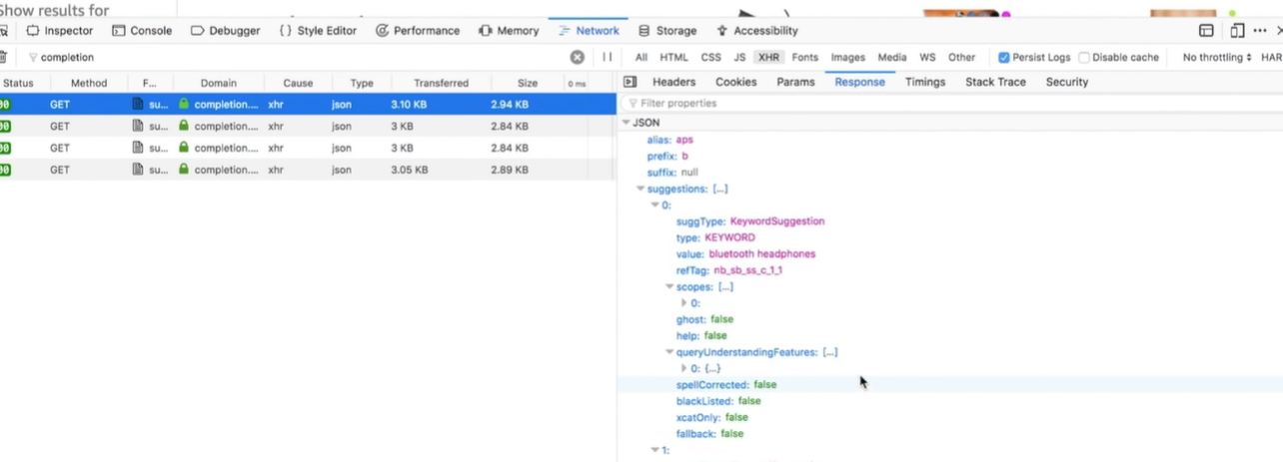

* APIs are public

#### MOBILE:

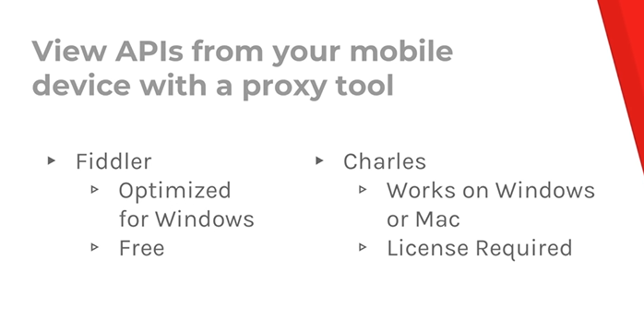

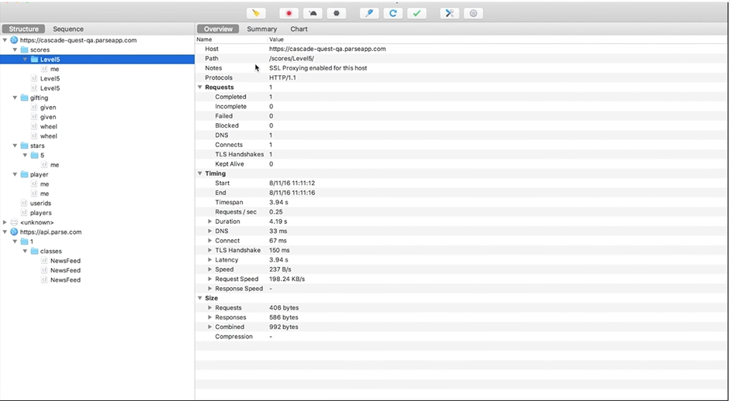

APIs are contracts that enable communication

### Exploring APIs with Postman

1.

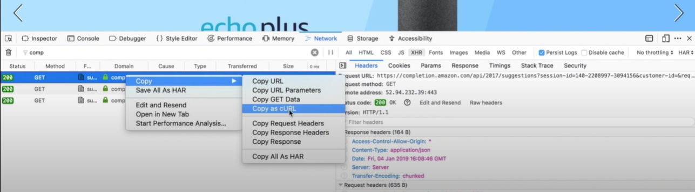

2.

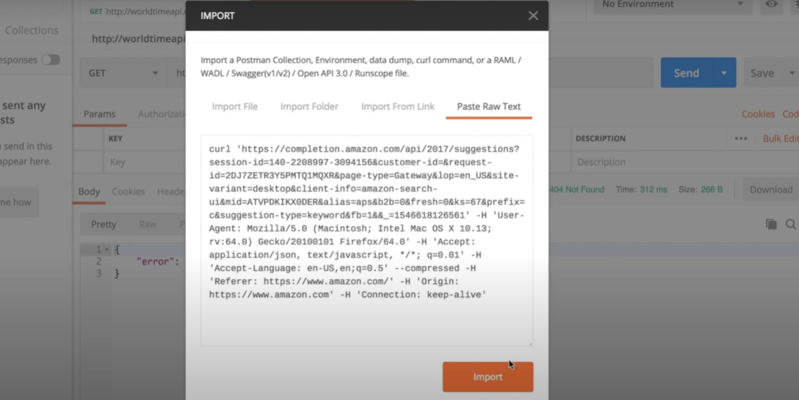

Result:

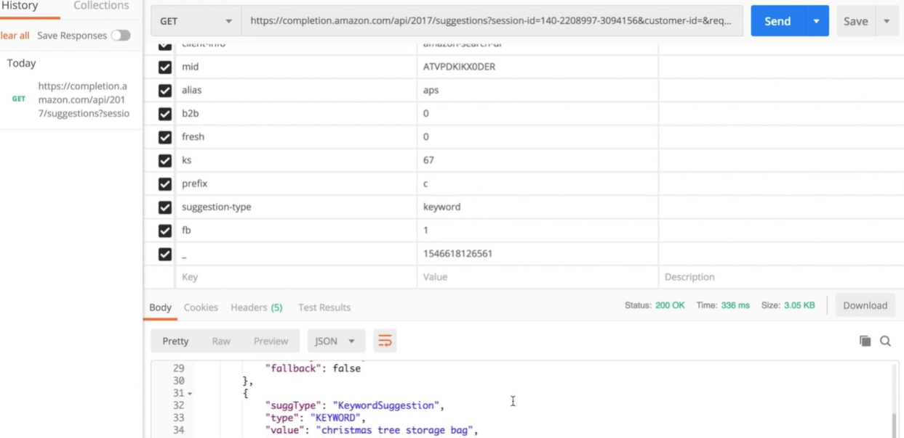

Post Request

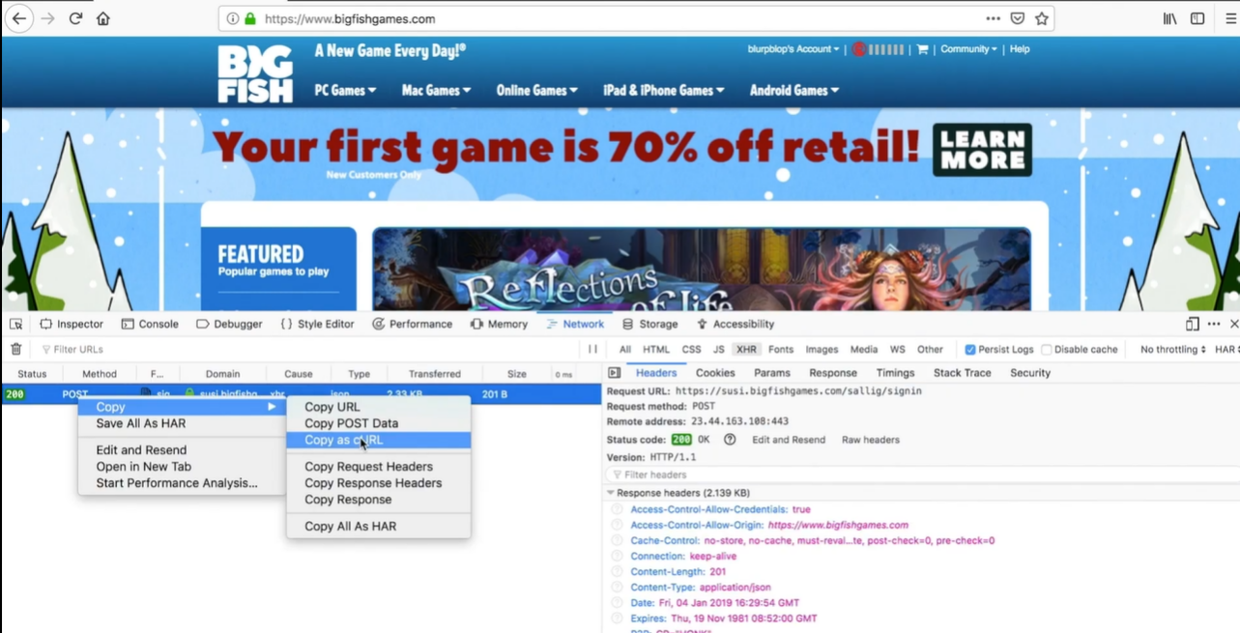

No info is in the URL

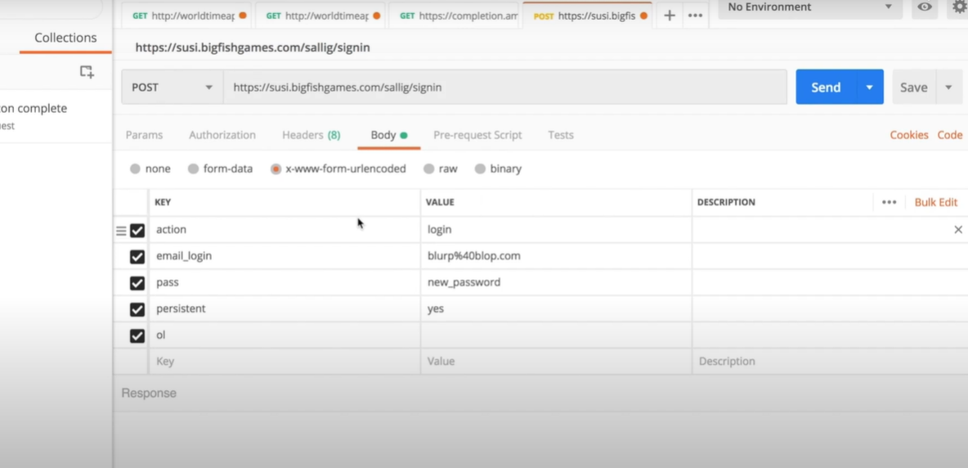

Response:

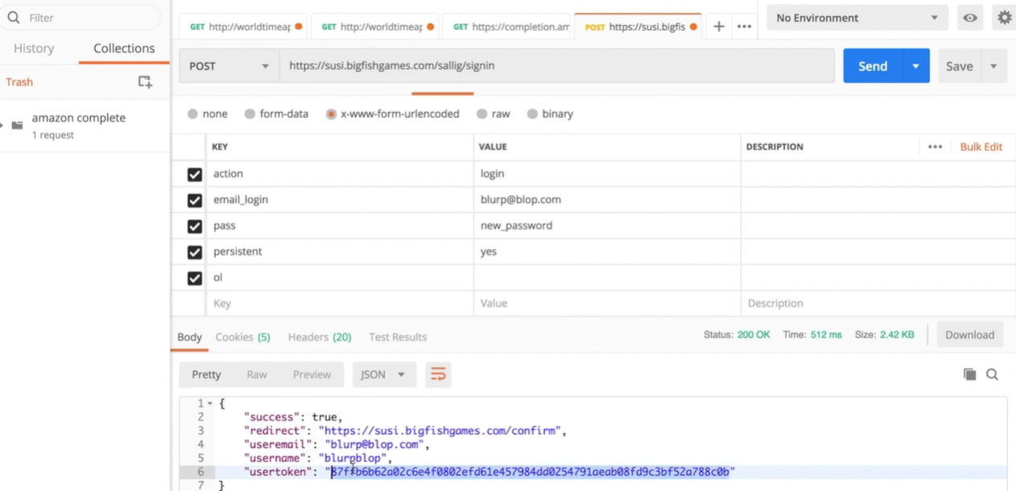

### Resource!

Restful booker API playground

restful-booker.herokuapp.com

Authorization token goes in

Headers tab

### API Testing Strategy

API’s:

* Correct
* Provide Value
* Intuitive

P O I S E D

**P**arameters

**O**utput

**I**nterop

**S**ecurity

**E**rrors

**D**ata

Add Environment

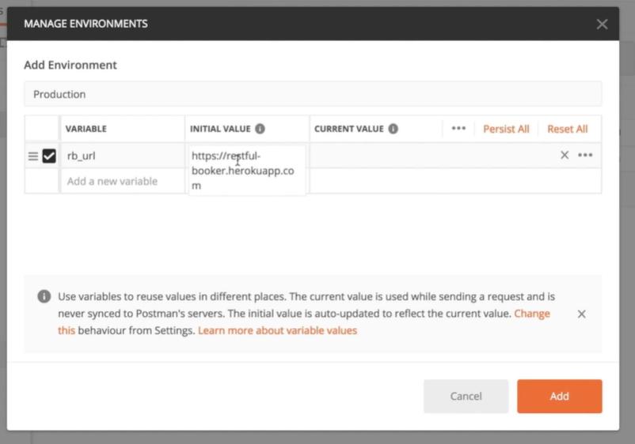

1. Select an Environment name in Add Environment field.

2. Select a URL name in the Variable field.

3. Paste the main URL of the tested website.

Now you can replace the url for the URL name chosen between two curly braces

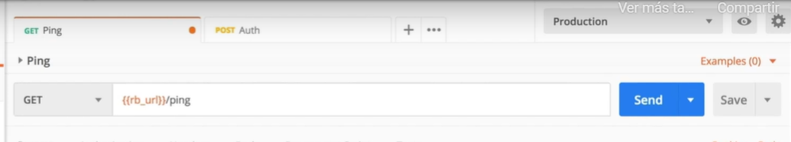

Adding authorization for all the collection:

1. Collection menu -> Edit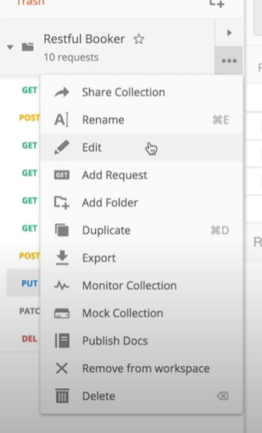
2. Choose the type of authorization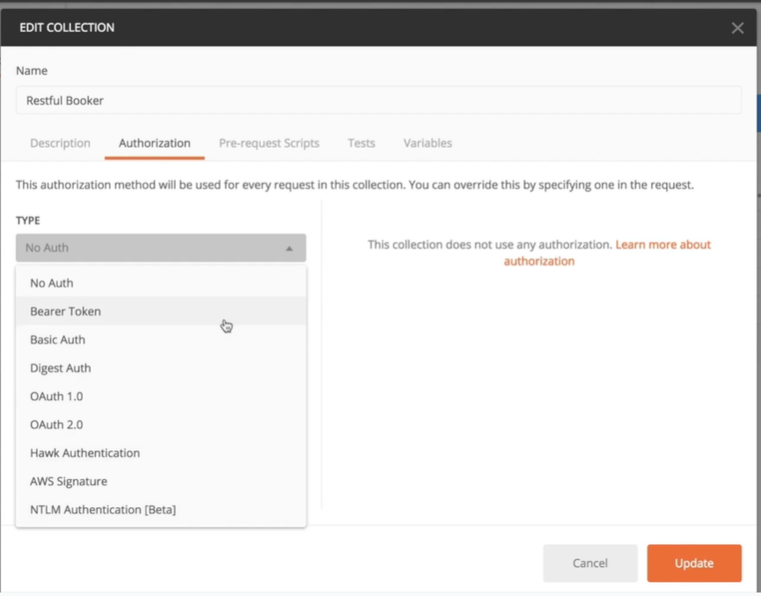

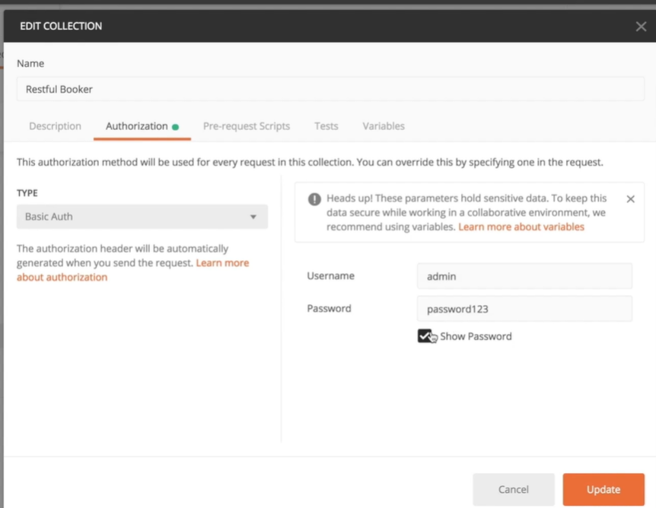

Click update

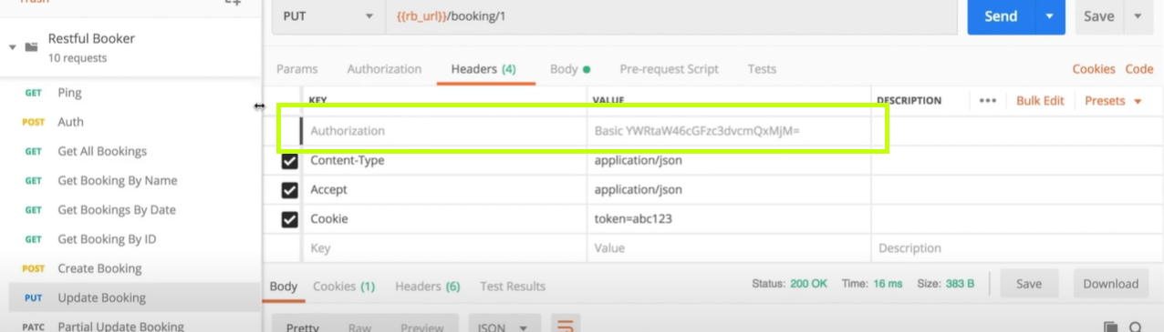

Authorization is now put there automatically by postman

#### PARAMETERS

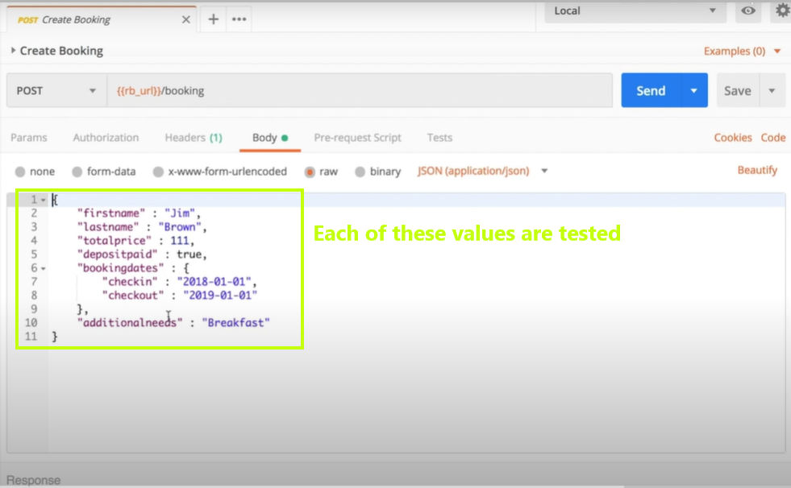

Tests that can be done:

“firstname” has no value

“firstname” field has space

“firstname” value is **null**

“firstname” value is not entered (erase “firstname” line)

“firstname” is a single letter

Invalid value in “depositpaid” (example: number, negative number, no value)

#### OUTPUT

Response

Status

Logs

etc

Headers:

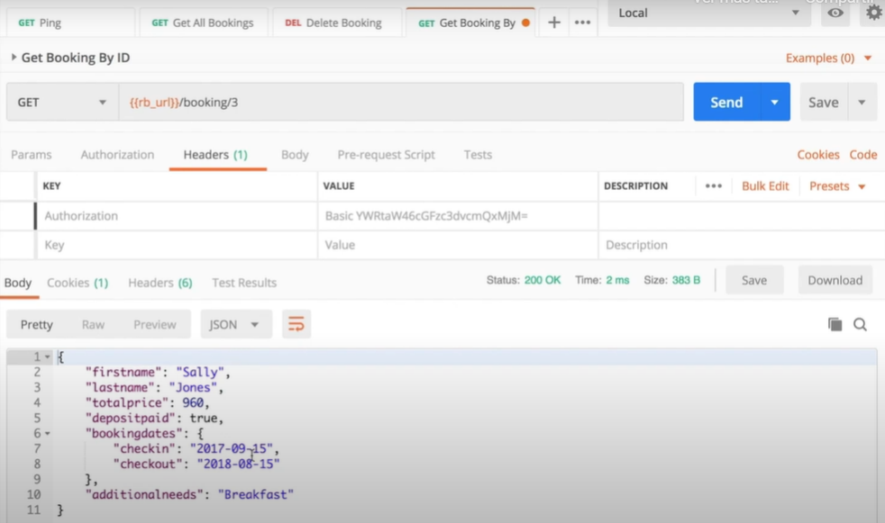

Accept application/xml

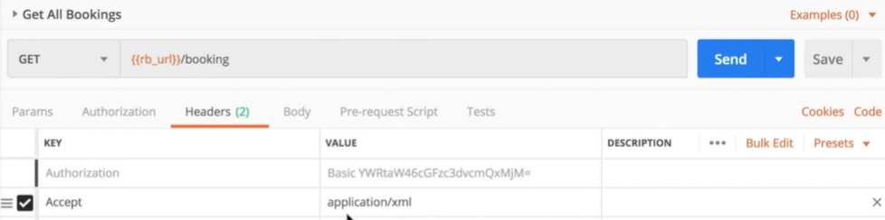

To see if endpoint is not processing headers correctly

#### INTEROP

API needs to be understandable for the software that it connects to.

Date format:

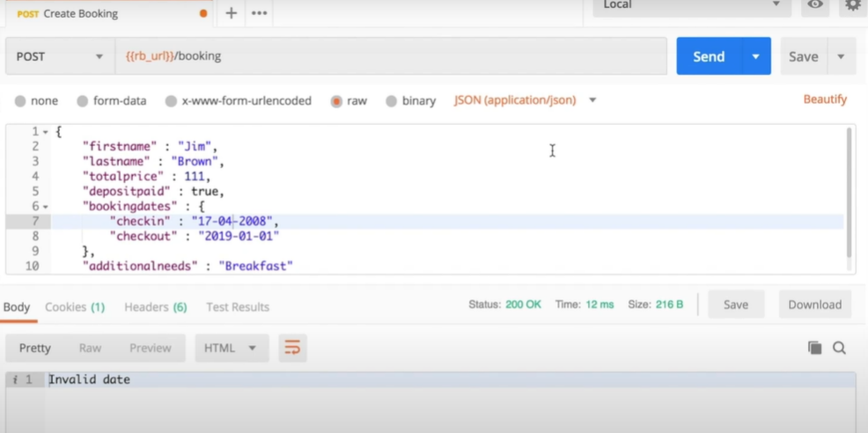

The goal is to review if the communication between those channels are easy to understand

#### SECURITY

Turn off the authorization header to see if the endpoint is still working or sends an error

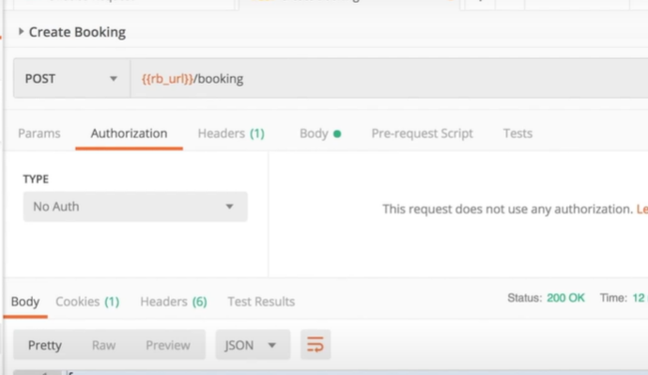

##### Cross-site scripting attack

Inserts a script so that when somebody loads the information into their browser the script is executed.

“firstname” has inserted a line on the format of a common script

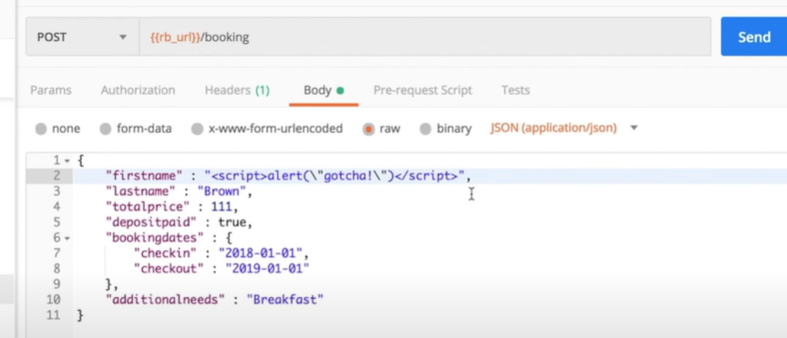

Verify if the script is inserted:

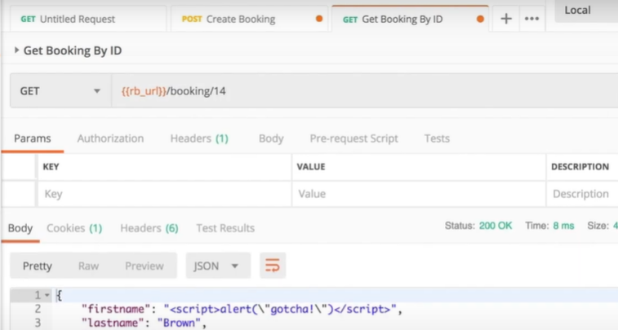

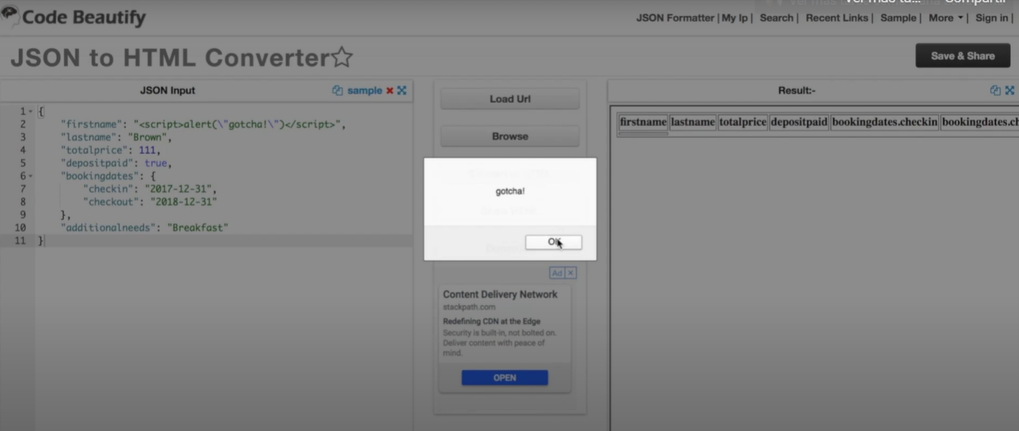

#### ERROR HANDLING

Incorrect credentials - Verify Response

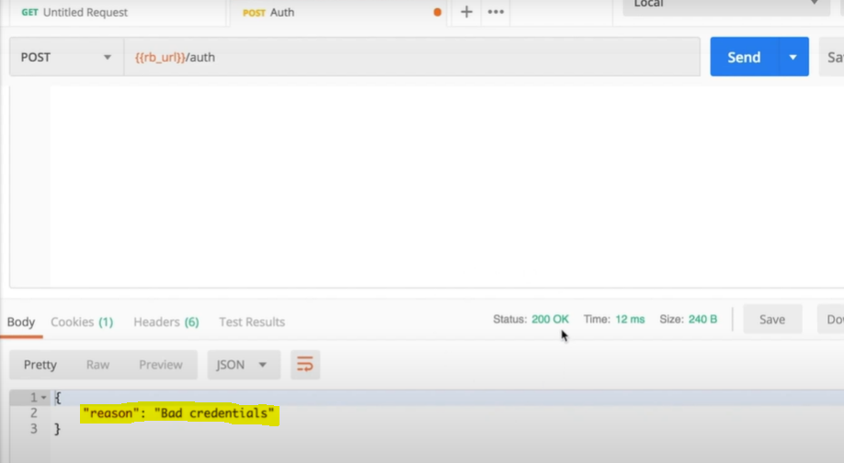

Invalid value

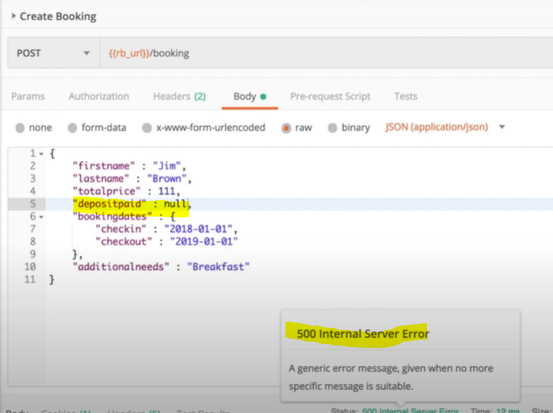

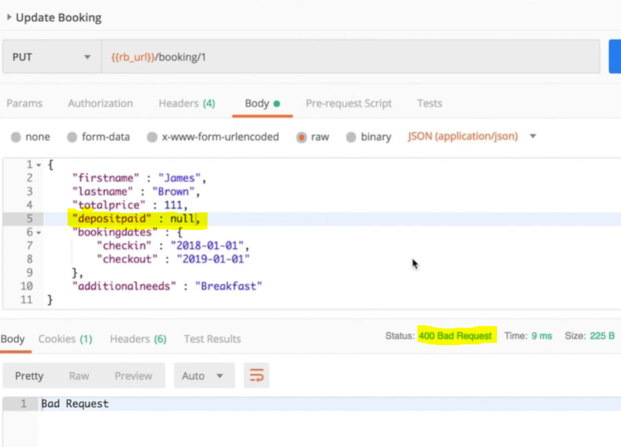

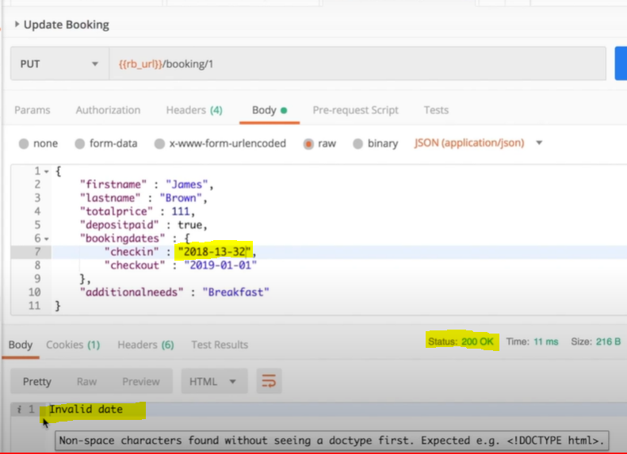

Messages should be clear and forbidden actions should not make any change in the database

#### DATA

Make sure that the data is being managed properly -> Verify by calling the API with the data received

Make sure that you’re collecting the data you need to have -> ex: Currency values has currency symbols

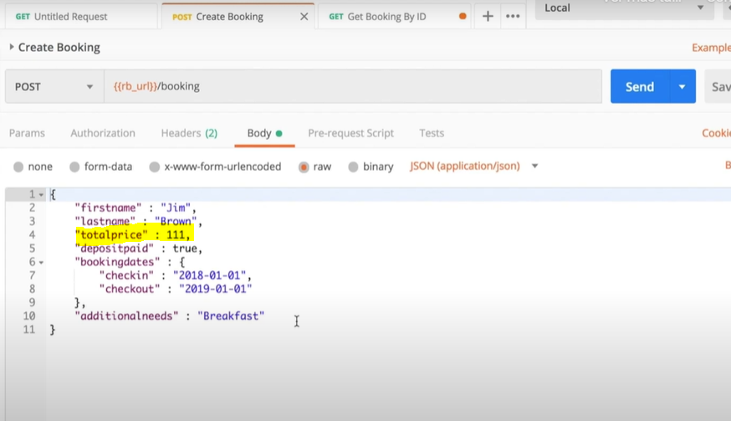

**Stress the API**

Create new collection

Paste the POST endpoint in the collection

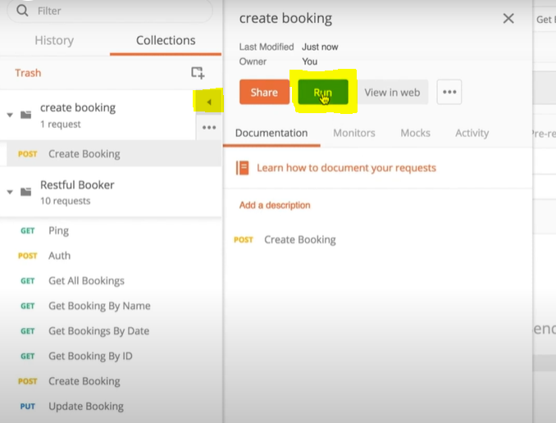

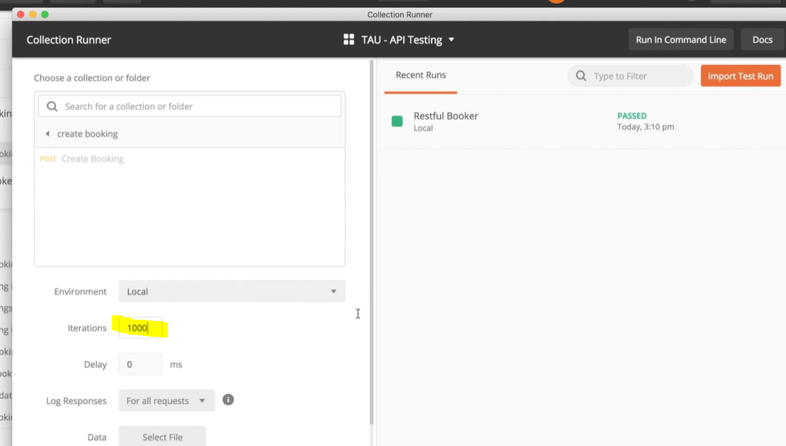

Run 1000 times and then make an individual request to check the loading time: 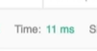

### Test Automation with Postman

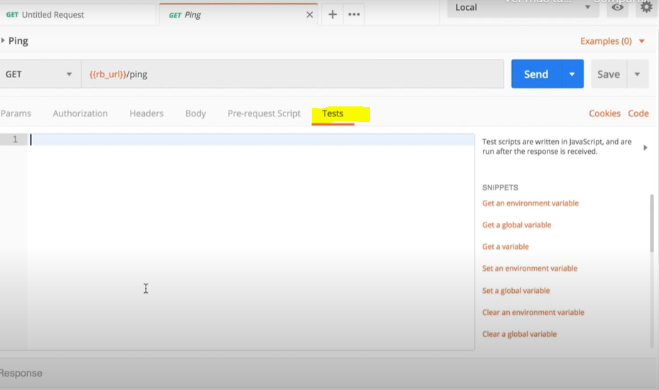

Snippet Status Code is 200:

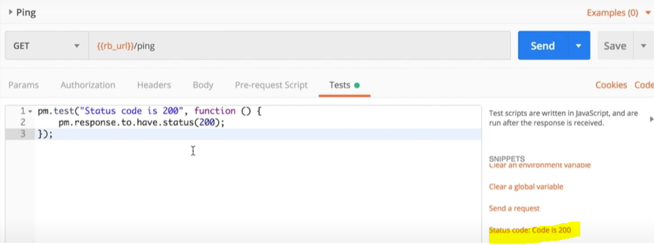

Results:

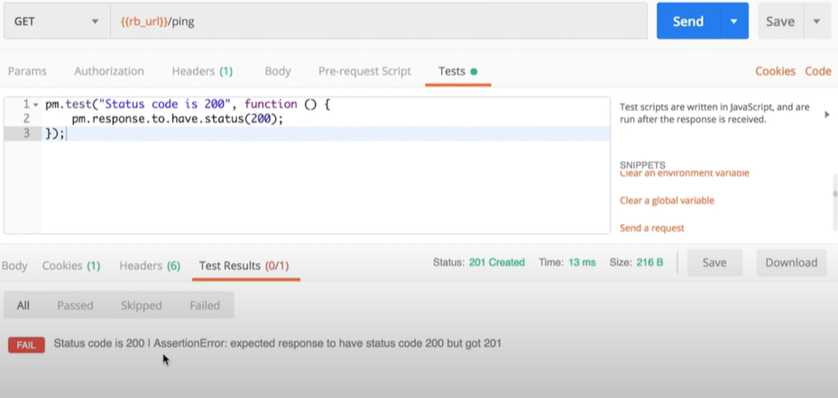

### Data-driven tests

To randomly assing value to a variable, put the value between two curly braces:

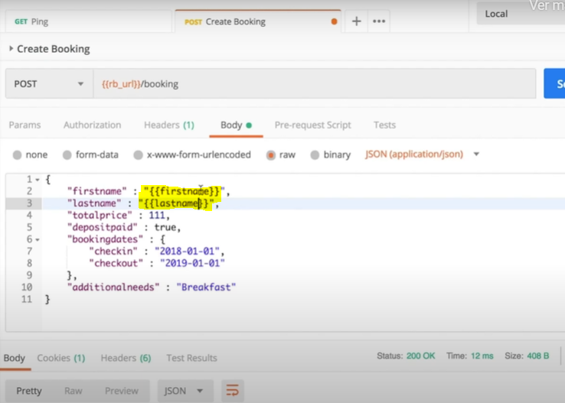

Create CVS file

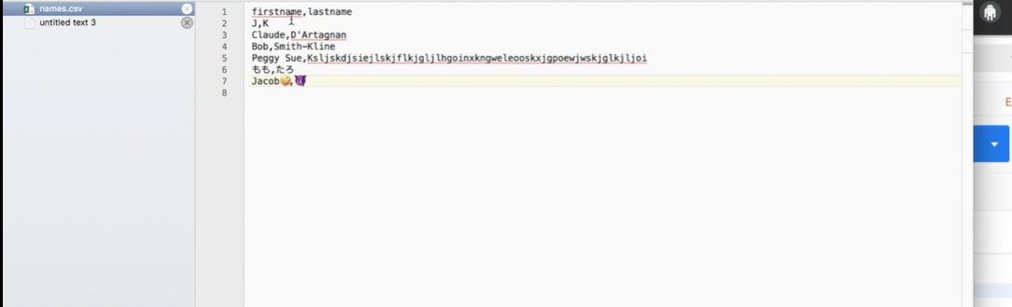

Use Snippets: Response body: JSON value check and Get Variable

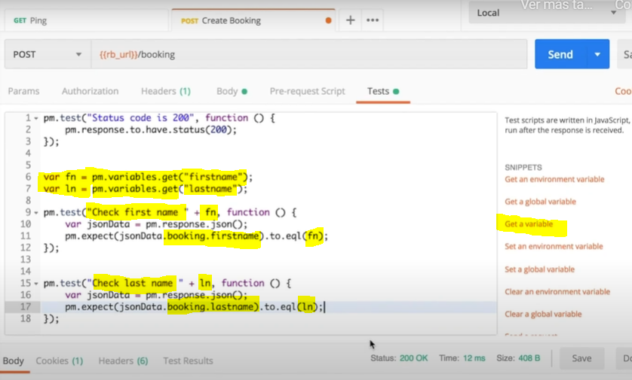

Go to the Collection Runner and select CSV File

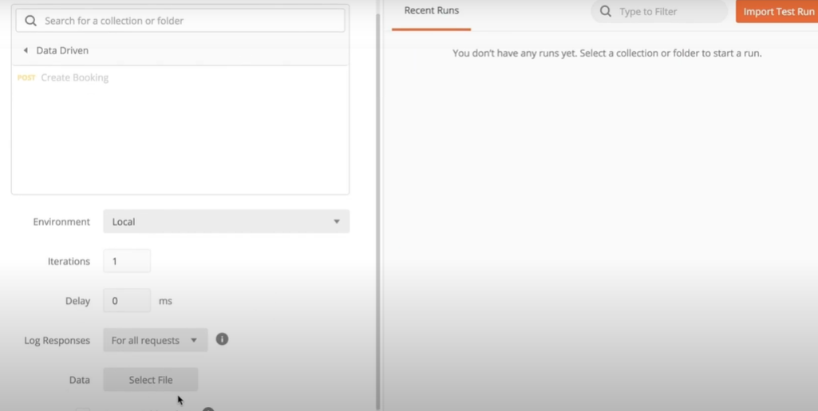

Click on run

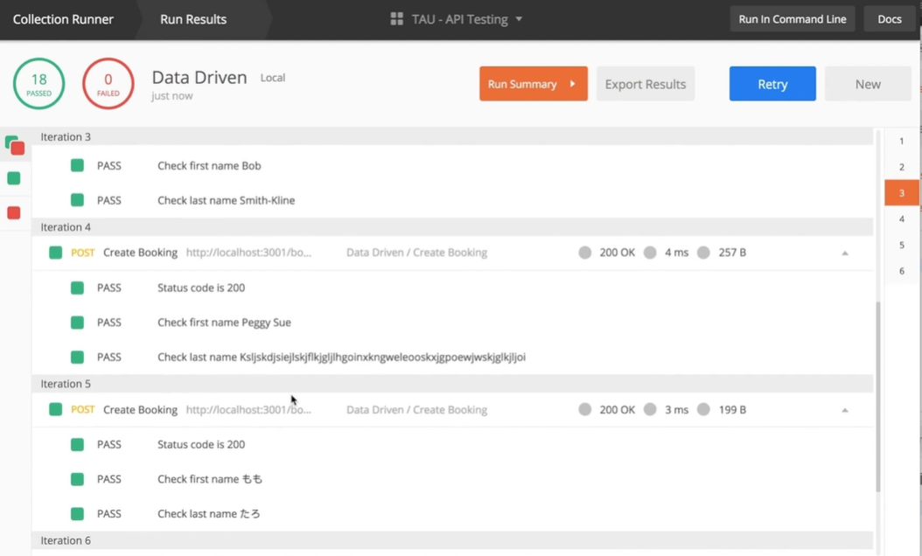

### Advanced API Tests

Postman Scripting docs

<https://learning.getpostman.com/docs/postman/scripts/postman_sandbox_api_reference>

In automation is important to know what the answer should be before you ask the question

Make a Collection for Smoke Tests Purposes

Random Booking generator:

Go to Edit Collection:

Go to Pre-request Scripts

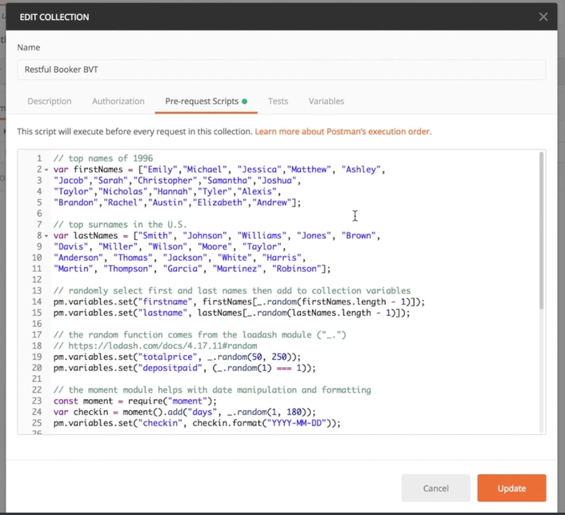

//randomly select first and last names then add to collection variables

pm.variables.set(“firstname”, firstNames[_.random(firstNames.length - 1)]);

pm.variables.set(“lastname”, lastNames[_.random(lastNames.length - 1)]);

This random functionality comes from a module called Lodash which is available automatically

(_. random(1) === 1)); is a coin flip to decide between true or false

[Lodash](https://lodash.com/) is a JavaScript library which provides utility functions for common programming tasks using the functional programming paradigm.

[Moment](https://momentjs.com/) is a JavaScript library which parses, validates, manipulates, and displays dates and times in JavaScript.

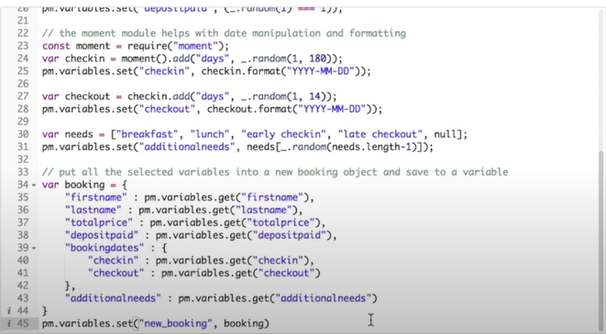

Create request

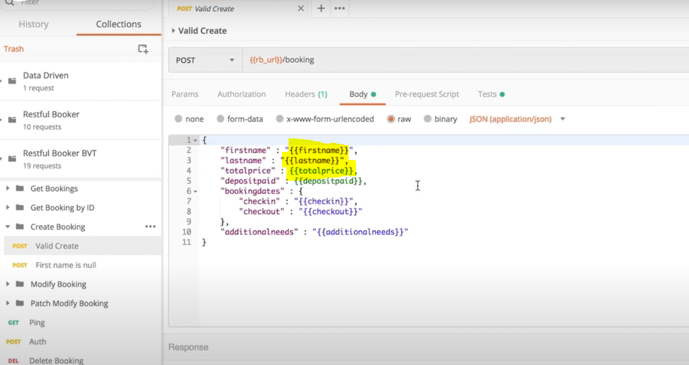

Press send:

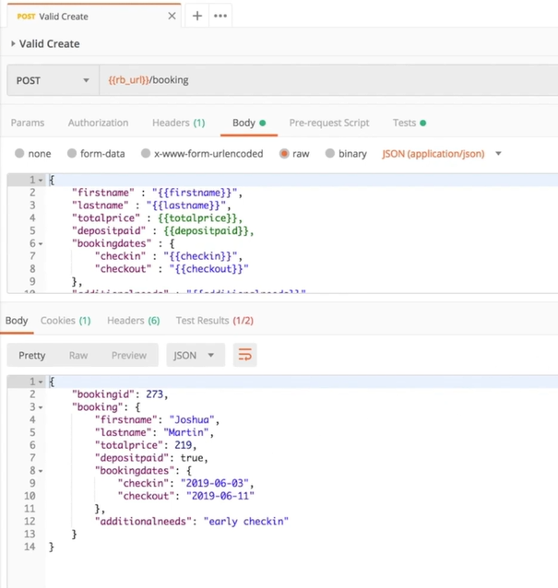

If we want to know if there exists a token value:

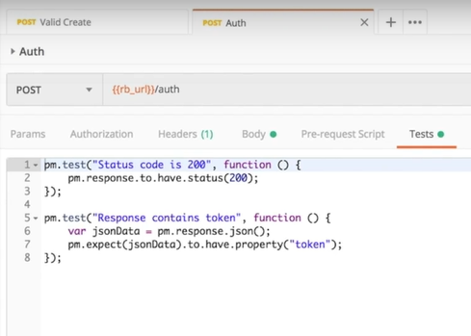

Make sure deletion is correctly done

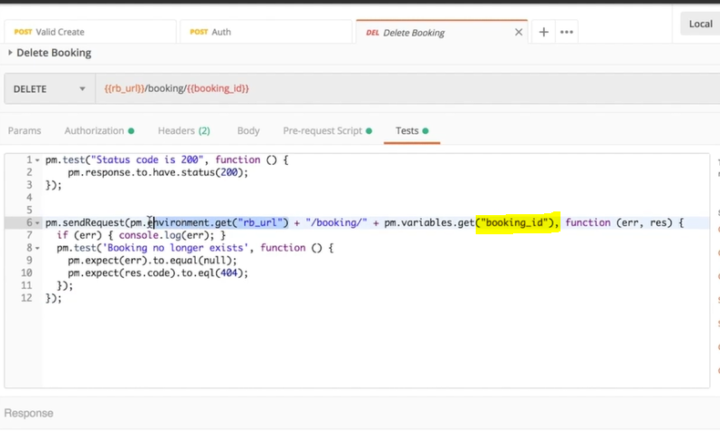

Open Postman Console to see more detail on the request.

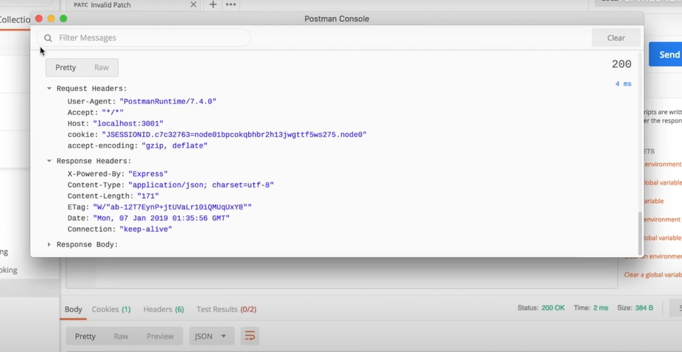

### Newman

Install node js

Install Newman

Export the collection to test (remove spaces in the name)

Download Environment to test

command:

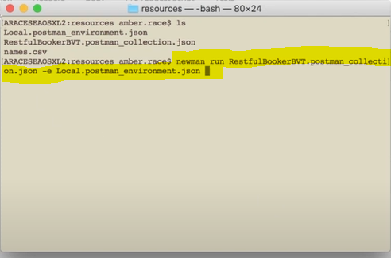

**newman run** NameOfTheCollectionFile.json **- e** NameOfTheEnvironmentFile.json

Basic report looks like

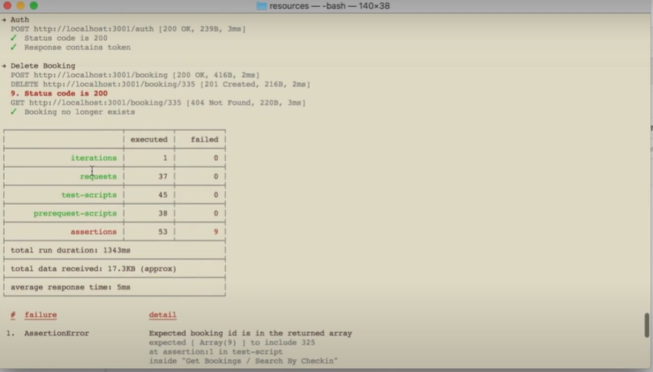

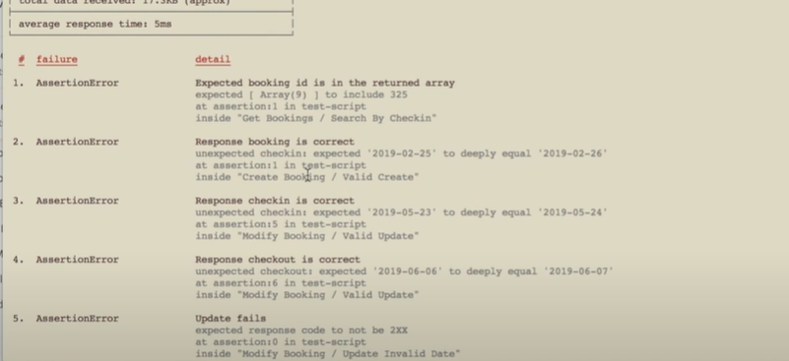

In Jenkins paste the command line

<https://github.com/DannyDainton>

He has a lot of interesting tools to format your Newman reports or more examples of interesting ways you can use Postman to do tests, so definitely check that out as well.

PUT is used to update data while POST can be used to create new data

Mocking

There are three main ways mocks can be created in Postman:

1. You can create a mock server that's based on a specification file. This is a really great option if you have the right documentation at hand, which details the API.
2. You can create a mock server from scratch, adding in requests and telling Postman what response data to return.
3. You can add a mock server to an existing Postman collection:

